Download the latest version of Citrix Workspace for Windows here: Citrix Workspace app for Windows, or for Mac here: Citrix Workspace app for Mac.
Open the downloaded file and select run.
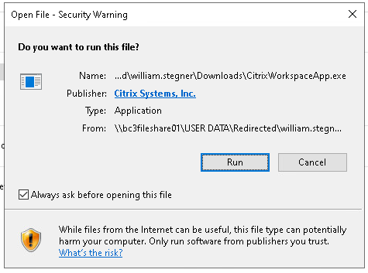
Screenshot
If it asks to allow the app to make changes, select Yes.
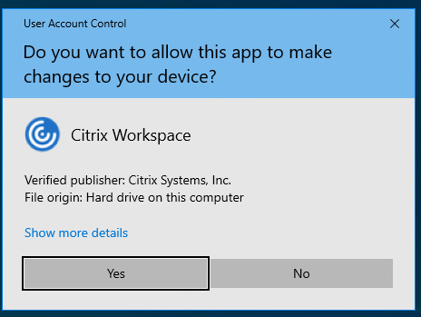
Screenshot
Click Start to begin the installation.
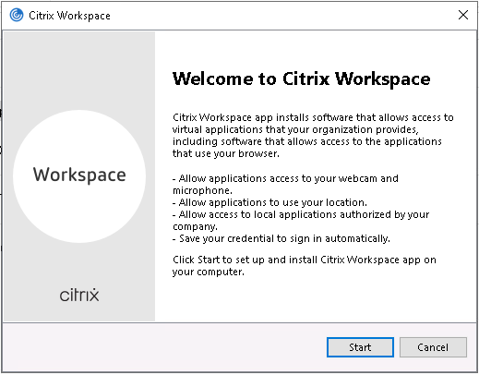
Screenshot
Click the check box to accept the license agreement and click next.
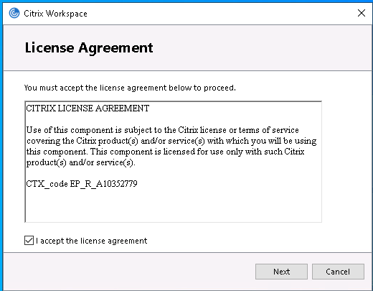
Screenshot

Click next on the following screen.
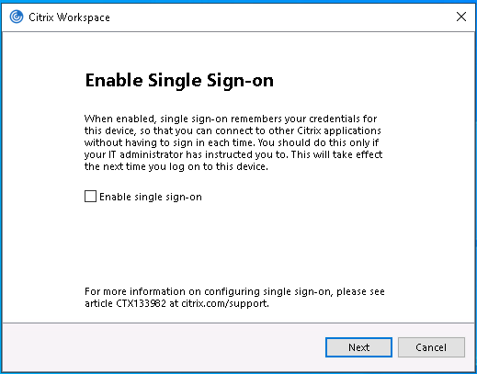
Screenshot

Next, click on the App protection box and click Install
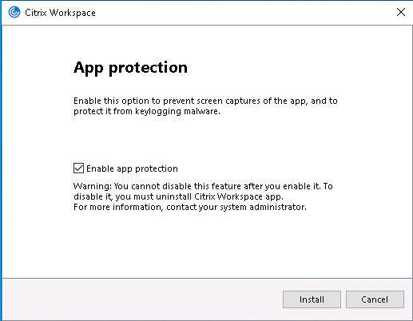
Screenshot

Once installed, click on Add Account.
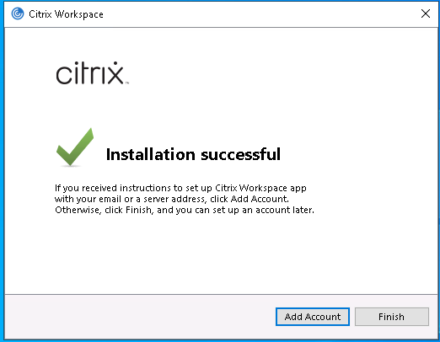
Screenshot

When prompted for a Store URL or email address enter: citrix.bc3.edu and click continue.
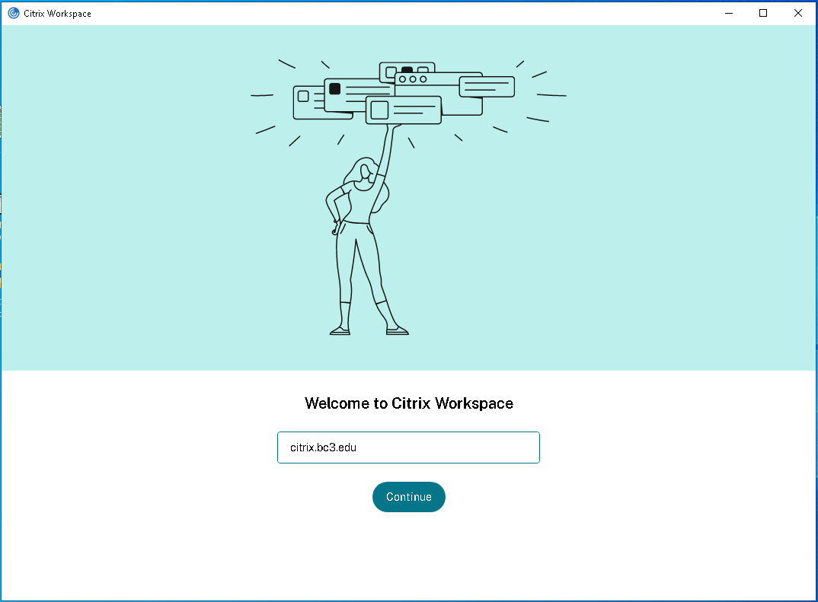
Screenshot

Enter your BC3 credentials and click Sign In.
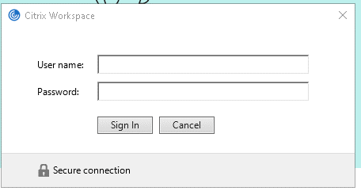
Screenshot

Enter your BC3 credentials again and click Log On.
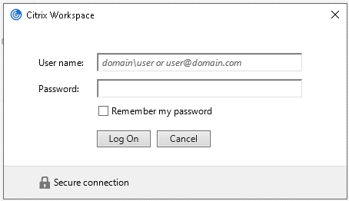
Screenshot

Click on the DESKTOPS tab and click on your needed resource.
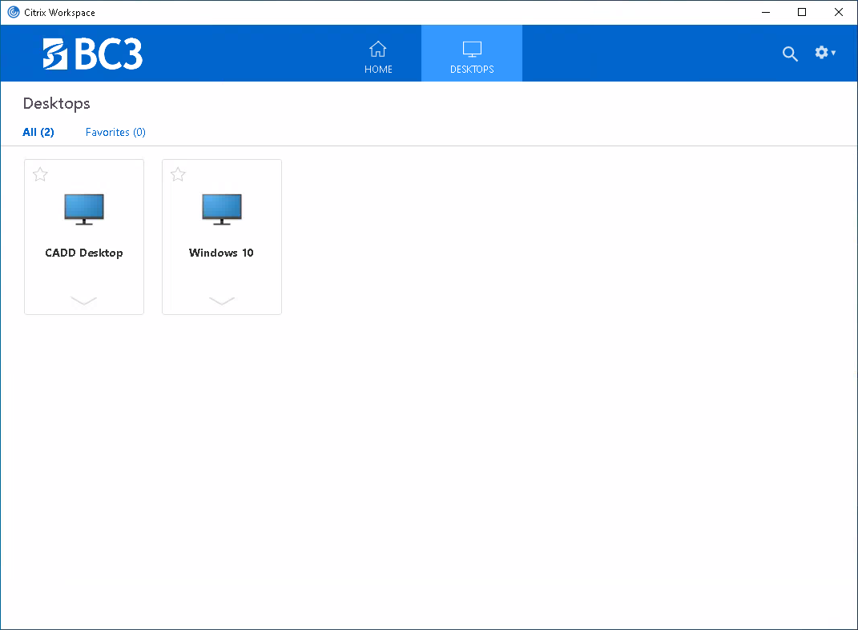
Screenshot

